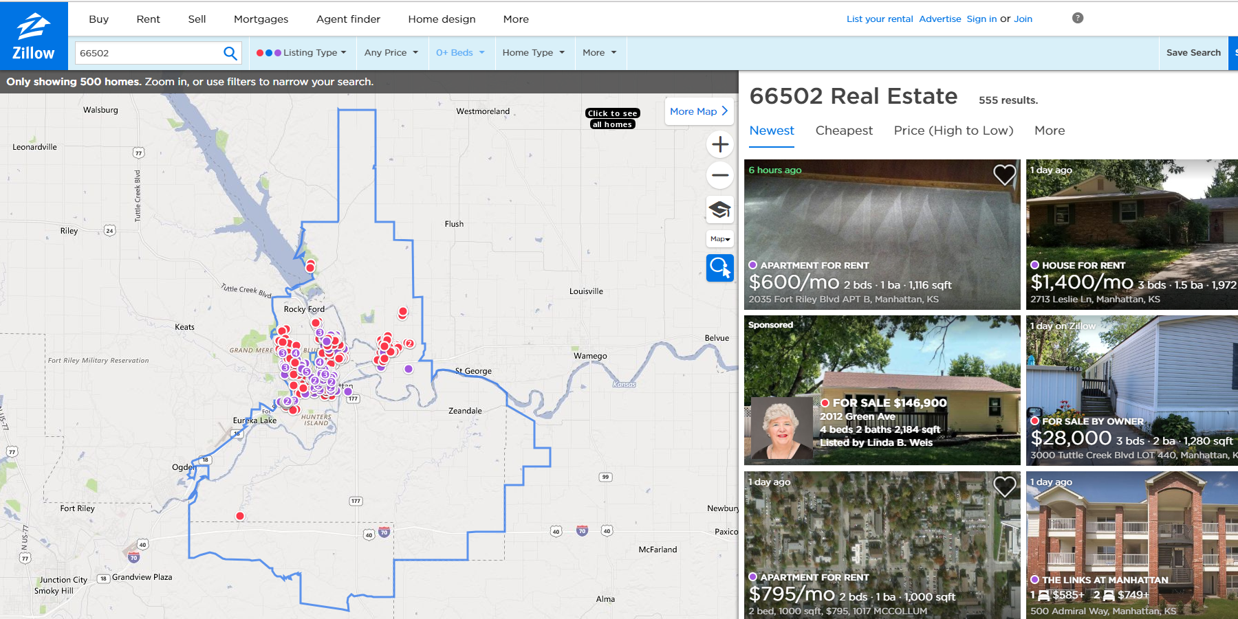

**URL for Manhattan, Kansas**

**https://www.zillow.com/homes/66502_rb/**

**Steps**

Download HTML of the search result page using Python Requests

Parse the page using LXML

Save the data to a CSV file

Requirement packages.

* Python
* Pip (To manage software package for Python)
* Pipenv (To install requests packages)
* Requests (To make requests and download the HTML content of the pages)
* LXML (To parse the HTML Tree Structure using Xpaths)
* Unicode CSV (To extract csv format)

Install Python

* In latest versions of Ubuntu, Python is already installed.
* Check the installed version.

python3 -V

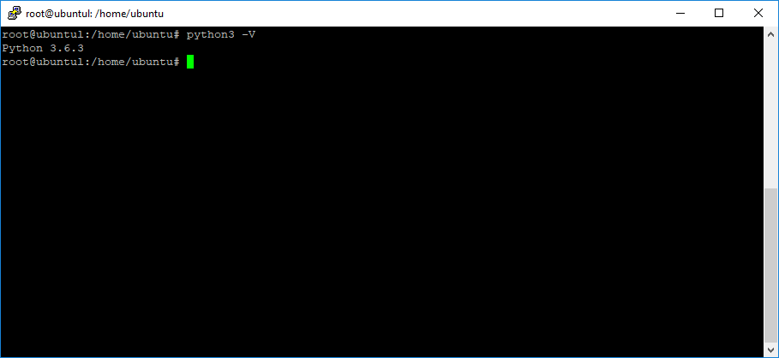

Install pip (To manage software package for Python)

sudo apt-get install -y python3-pip

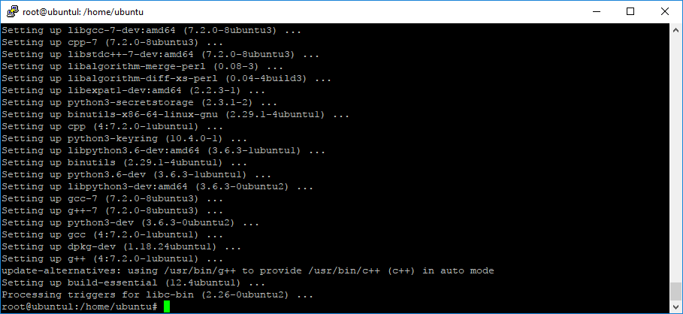

sudo apt install python-pip

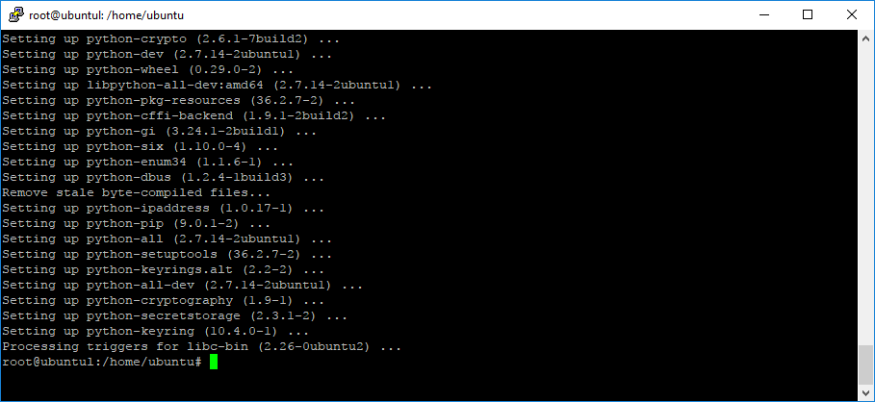

Install pipenv (To install requests packages)

pip install pipenv

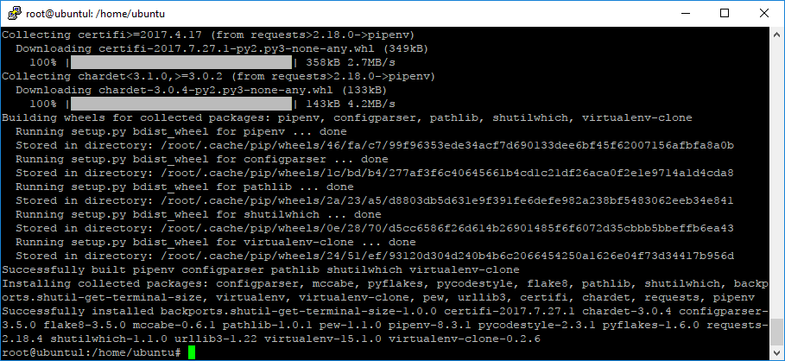

Install requests package (To make requests and download the HTML content of the pages)

pipenv install requests

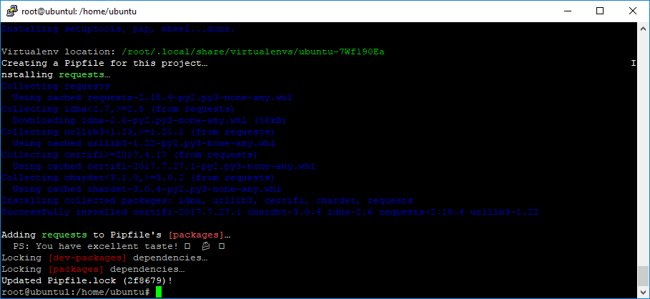

Install LXML (To parse the HTML Tree Structure using Xpaths)

sudo apt-get install python3-lxml

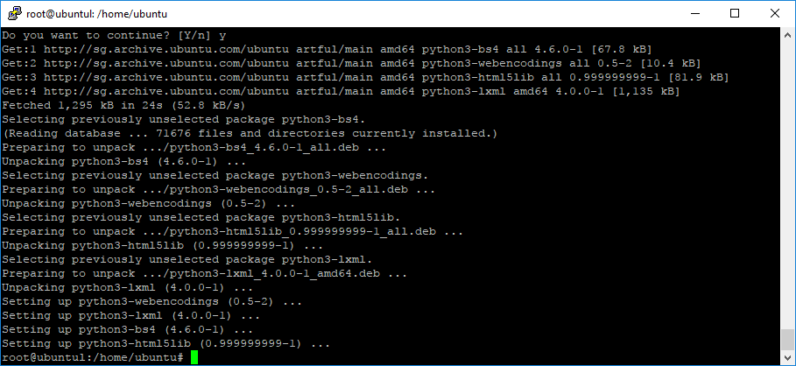

pip install lxml

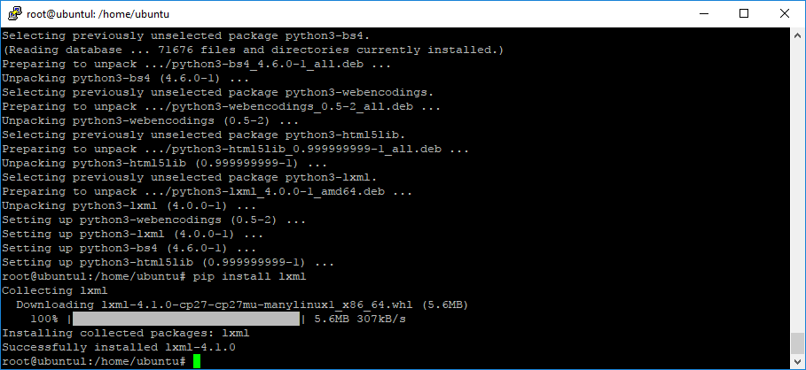

Install Unicode CSV

sudo pip install unicodecsv

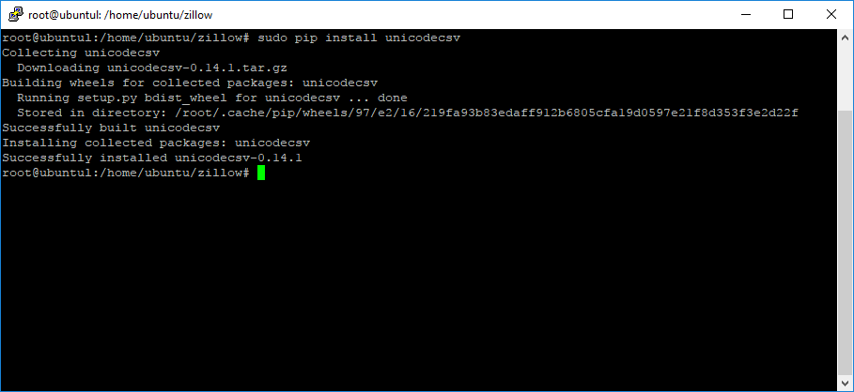

Upload the script

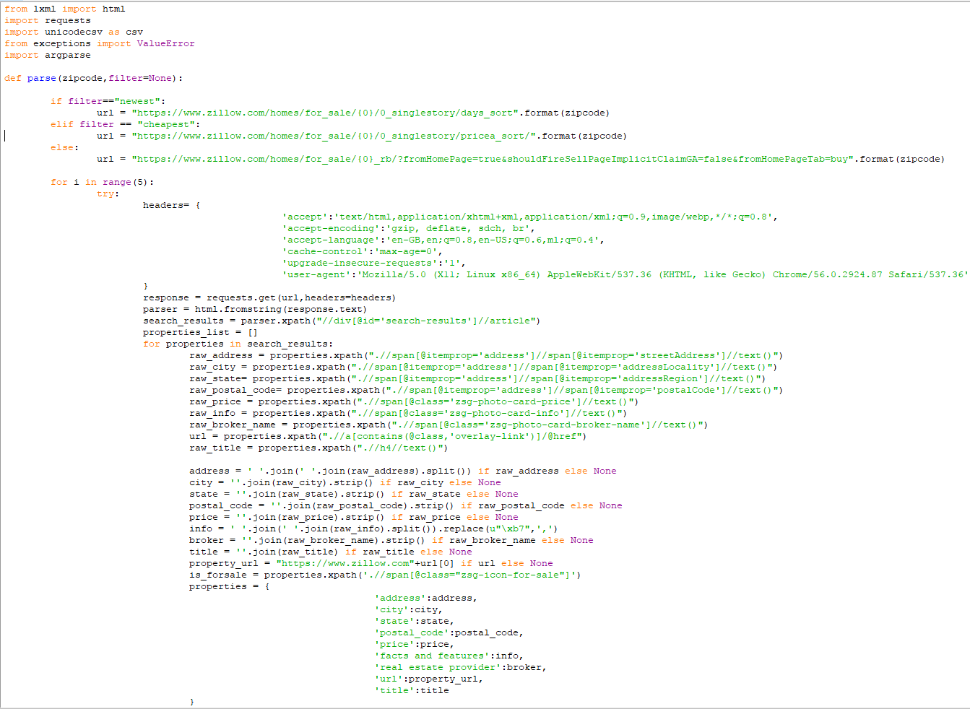

Scraping data

python zillow.py 66502 newest

(or)

python zillow.py 66502 cheapest

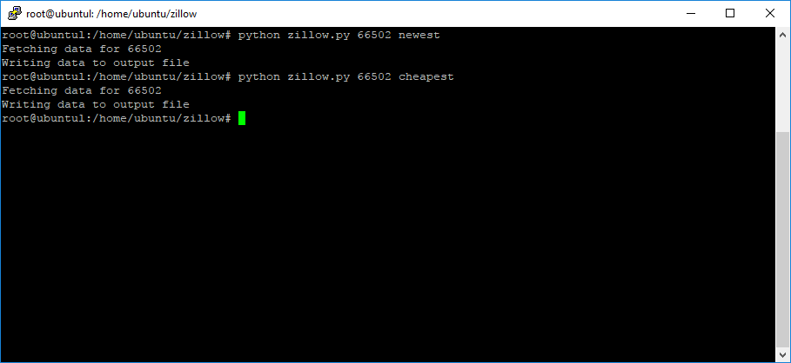

Result

